

Candidate Information Pack

<Month year>

Project Support Assistant

<Month year>


Closing date: 12 noon Monday 19th January 2026

<Month year>



Contents

Introduction | 3
About Us | 4
What we do | 5
How we’re organised | 6
Strategic direction | 7
Benefits of working for us | 8
How to apply / Data Protection | 9
Job Description | 10-12
Person Specification | 13

Introduction

Dear Candidate
Thank you for your interest in joining the Sustainable Living Team at Footprints Women’s Centre.
Since 1991, Footprints has been an anchor organisation supporting positive change in the lives of women, children, and the wider Colin community.
As the largest community employer in the area, our multi-service centre is an inclusive, friendly, and Green Flag Award-winning space.
Our work spans from drop-in support and crisis intervention to education, sustainable living initiatives, and childcare provision.
You can find out more about our organisation and this role in the Information Pack or by visiting our website at www.footprintswomenscentre.org
We are a small, dynamic team with a diverse workload. We collaborate widely with community and sector partners and are excited by the growing opportunities to advance our strategic priorities across the women’s sector — particularly in relation to climate action and sustainability.

We are a values-driven employer, offering excellent working conditions and believe that creating positive change begins within our own team, fostering an environment where everyone is respected, supported, and inspired to make a difference.
I hope you will want to be part of our journey as we work to grow women-led climate action and community sustainability across Northern Ireland.

Yours sincerely

Lisa Maclean
Chief Executive

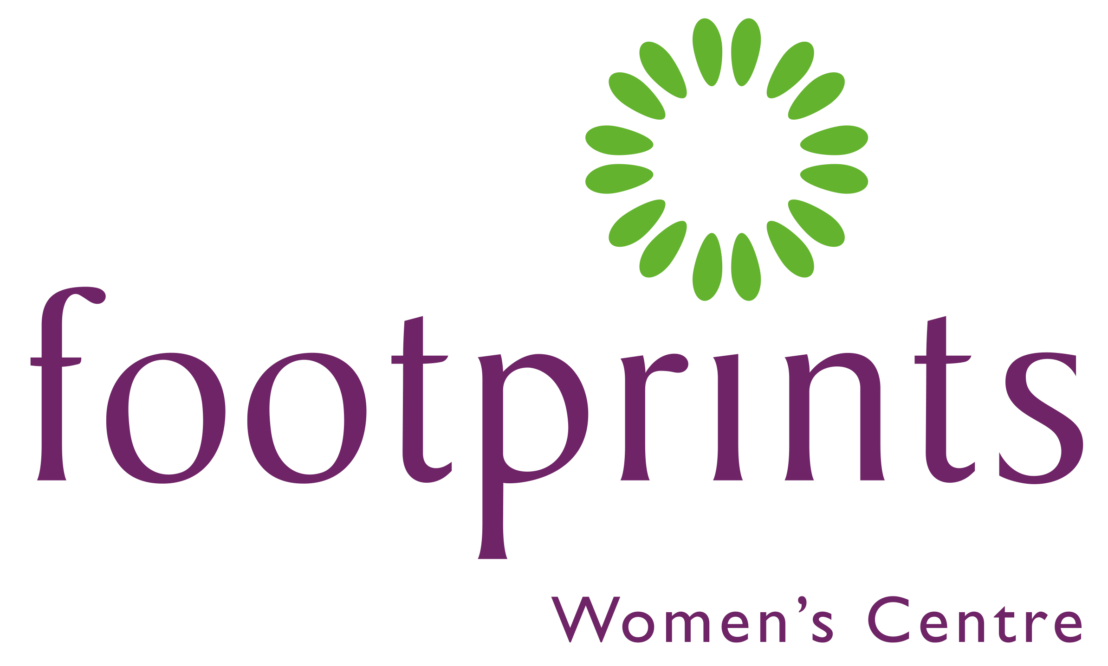



About Us

Our Mission
To enable women and children to ensure their voices are heard and that they take their rightful place in a just and equal society.

Our Vision
To eradicate inequalities that impact upon the lives of women and children.

Our Values

- To demonstrate Respect, listening actively to others and being non-judgemental.

- To provide Support through matching need.

- To underpin work with a Feminist Ethos that raises awareness of the inequalities experienced by women in society and provide interventions to redress the imbalance.

- To uphold Equality and recognise the value of Diversity across support delivery.

- To maintain Confidentiality in all our work and establish clear boundaries in the support we provide.

- To demonstrate Commitment to Footprints and generate positive energy and welcoming friendly atmosphere individually and collectively.

What we do

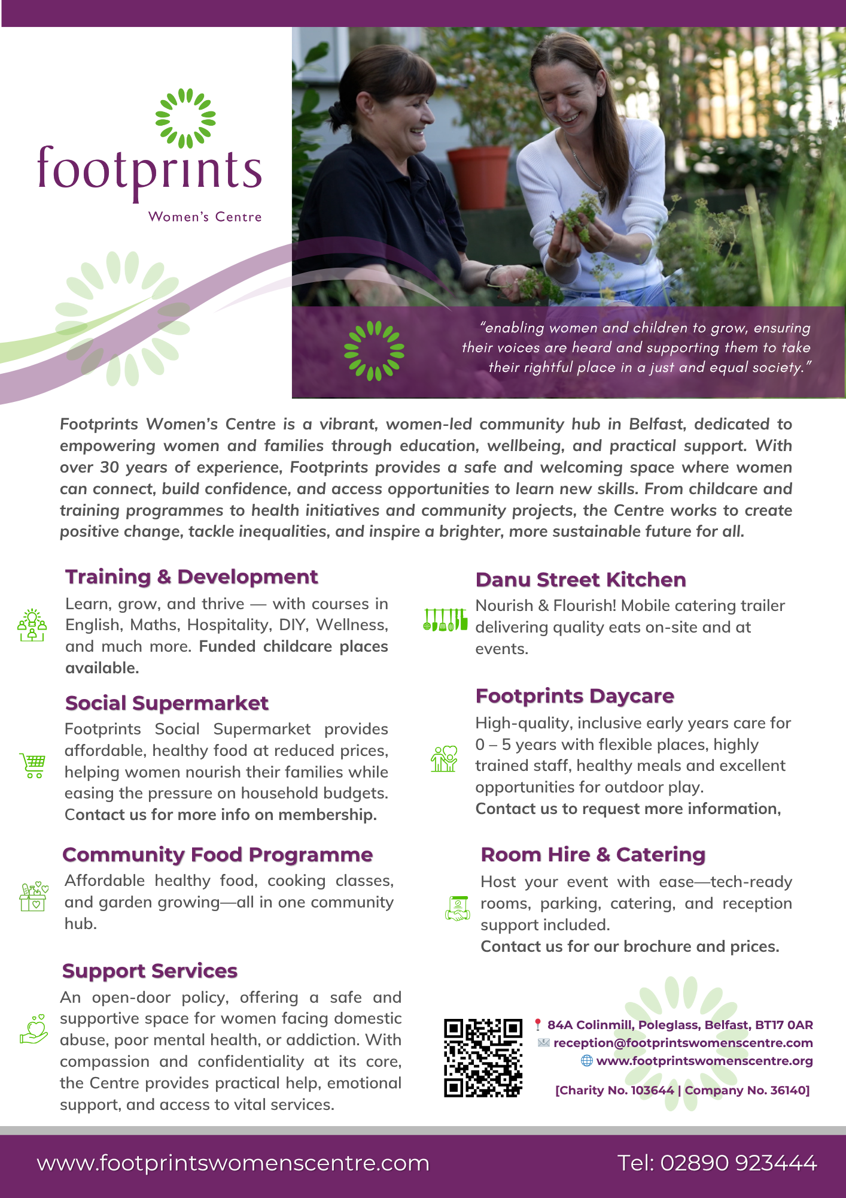

How we’re organised
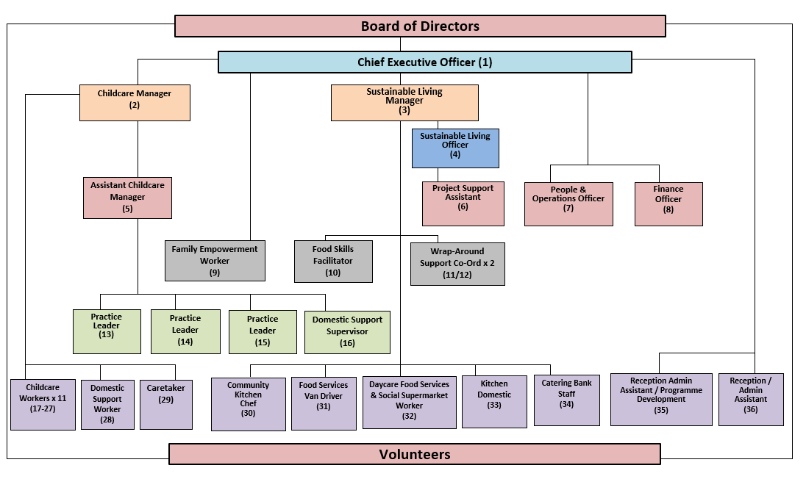

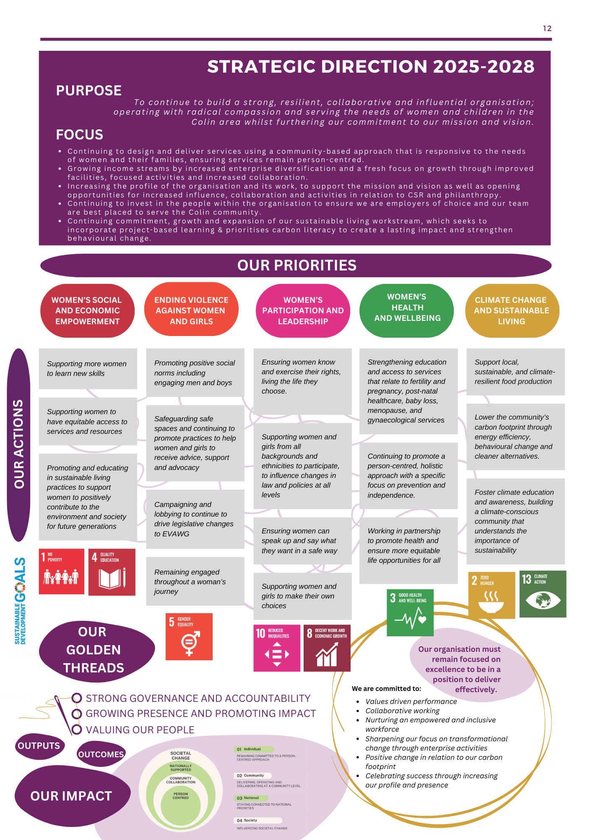

Benefits of working for us

1. Purpose-Driven Work

Contribute to meaningful change by advancing gender equality and climate justice.

2. Collaborative Culture

Be part of a supportive, inclusive team that values diverse voices and shared leadership.

3. Professional Growth

Access opportunities for training, mentorship, and skill development in gender, climate, and advocacy work.

4. Flexible Working Arrangements

Enjoy hybrid work options, flexible schedules and a focus on work-life balance.

5. Inclusive and Safe Workplace

We foster a work environment that prioritises care and respect.

6. Global and Local Impact

Collaborate with partners and communities driving feminist solutions to climate and social justice issues.

7. Comprehensive Benefits Package

- Competitive salary: £25,480
- 22 days paid leave plus 11 customary days each year
- Wellness support
- Flexi-time arrangements
- Pension contributions – 3% employer contribution
- Personal development training
- Staff Appreciation Scheme

How to apply

Applicants are requested to submit the following documents as part of their application.

All submissions should be received by the closing date:
12 noon Monday 19th January 2026.

To apply for this role please send the following information to: people@footprintswomenscentre.com

- ​An up-to-date CV (please send in word format)
All personal information will be removed before shortlisting is undertaken

- A supporting statement to a maximum of two sides of A4.
Please outline how your knowledge, skills, experience and values meet the requirement of the role.

- Competed Equal Opportunities Monitoring Form
This form will be removed before shortlisting is undertaken.

- Completed Referees Form
This form will be removed before shortlisting is undertaken. The form should have details of two referees; one should be your most recent employer if you have one. Referees will not be contacted unless you are successful at the interview stage.

We will contact you to advise if you have been shortlisted for interview.

Interviews will be held:
Week commencing: 2nd February 2026

Data Protection (UK GDPR)

All personal information provided during the recruitment process will be handled in accordance with the UK General Data Protection Regulation (UK GDPR) and the Data Protection Act 2018. Your data will be used for recruitment and selection purposes only, stored securely, and retained only as long as necessary. We will not share your information with third parties except as required for recruitment checks or by law.

Job Description

Job Title: Project Support Assistant

Responsible to: Sustainable Living Officer

Location: Footprints Women’s Centre, 84a Colinmill, Belfast, BT17 0AR

Hours: 35 Hours per week

Salary: £25, 480; 3% employer pension contribution;

Leave entitlement: 22 days plus 11 statutory holidays

Introduction
Climate Conscious Communities is a five-year initiative, funded by National Lottery Community Fund, led by Footprints Women’s Centre (FWC) in partnership with Keep Northern Ireland Beautiful (KNIB), Fareshare NI and PricewaterhouseCoopers (PwC). It seeks to empower women and girls in communities across Northern Ireland to lead locally driven climate action and advocate for feminist climate justice. The project addresses both the structural inequalities that women face and the urgent need for community-level climate mitigation through practical, meaningful, and co-designed action.
Project Support Assistant Role
Footprints Women’s Centre is seeking a motivated Project Support Assistant to help champion our environmental initiatives. This new and exciting role will assist the Sustainable Living Officer in implementation and delivery of project activities, providing administrative, co-ordination and communication support to help drive forward our vision to engage and empower women’s centres, their members and wider communities across Northern Ireland to adopt environmentally sustainable behaviours and promote climate-conscious living.

Key Roles and Responsibilities

1. Project Administration & Support
- Provide day-to-day administrative support to ensure the smooth delivery of project activities.
- Assist the Sustainable Living Officer in organising project schedules, meetings and milestones.
- Support contract and procurement processes through document preparation, logging information and maintaining accurate records.
- Monitor inboxes, respond to general enquiries and ensure communications are directed appropriately.
- Support the coordination of events, workshops including logistics and follow-up actions.
- Ensure compliance with organisational policies, safeguarding, data protection and funder requirements.
- Carry out administrative duties as required to support project delivery.

2. Communications & Engagement
- Assist in project communications, including social media updates, newsletters and digital content.
- Assist in the preparation of promotional material, case studies and presentations.

3. Stakeholder Coordination
- Support the Sustainable Living Officer in maintaining effective relationships with project partners, Women’s Centres and other community organisations.
- Coordinate meetings and monitor action points.

4. Monitoring, Evaluation and Reporting
- Maintain accurate project records, files, databases in with GDPR and Footprints policies.
- Support the maintenance of accurate records, producing progress reports as required.
- Assist in gathering feedback and reviewing project outcomes.
- Ensure monitoring and evaluation frameworks to track impact and outcomes are maintained.
- Assist in progress updates for the project steering group and other relevant committees.
- Collect qualitative and quantitative data to inform ongoing improvement and accountability.

5. Personal and Professional Development
- Participate in Footprint’s performance appraisal process.
- Participate in staff training as and when required.
- Undertake any other duties as required that are appropriate to the evolving needs of the post.
- Ensure adherence to all Footprints policies and procedures.
Please note:
All staff are required to undergo Access NI checks with the Police Service for Northern Ireland and must be appropriately vetted for the protection of children and vulnerable adults at risk prior to commencement of employment.

Person Specification

Specification | Essential | Desirable
A Level 3 qualification in a relevant field, or  A Level 2 qualification and at least 2 years of relevant experience. | √
Proven experience in an administrative or project support role | √
Experience of maintaining accurate records or databases | √
Experience of using social media, Canva or other content tools | √
Experience working within the Women’s Sector, community development or a charitable organisation |  | √
Strong written and verbal communication skills | √
Strong organisational and time management skills | √
Proficient in Microsoft Office | √
Ability to work in a team environment and independently | √
Ability to take initiative and contribute ideas | √
Knowledge of community development | √
Strong attention to detail | √
Basic budgeting or financial tracking skills |  | √
A demonstrated interest in sustainability, environmentally conscious practices, and/or issues affecting women and girls | √

Footprints Women’s Centre
84a Colin Mill
Poleglass, Dunmurry
West Belfast
BT17 0AR

Charity Registration NIC103644 | A Company Limited by Guarantee NI036140

Please address any enquiries relating to the advertised position, and your submission to:

Charlene Murray
People & Operations Officer
Footprints Women’s Centre

Tel: 02890 923444
Email: people@footprintswomenscentre.com

