

Candidate Information Pack

<Month year>

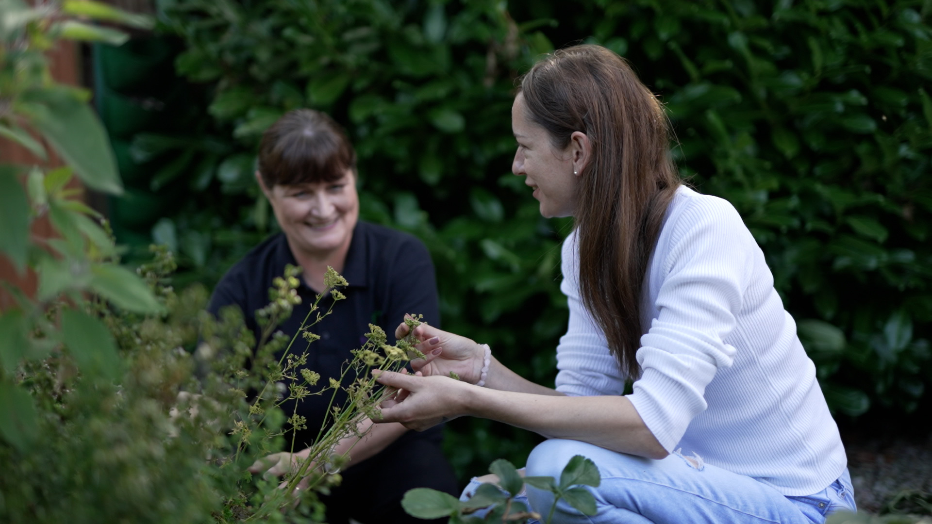
Closing date: 12 noon Monday 19th January 2026

<Month year>
Sustainable Living
Officer

<Month year>



Contents

Introduction | 3
About Us | 4
What we do | 5
How we’re organised | 6
Strategic direction | 7
Benefits of working for us | 8
How to apply / Data Protection | 9
Job Description | 10-12
Person Specification | 13-14

Introduction

Dear Candidate
Thank you for your interest in joining the Sustainable Living Team at Footprints Women’s Centre.
Since 1991, Footprints has been an anchor organisation supporting positive change in the lives of women, children, and the wider Colin community.
As the largest community employer in the area, our multi-service centre is an inclusive, friendly, and Green Flag Award-winning space.
Our work spans from drop-in support and crisis intervention to education, sustainable living initiatives, and childcare provision.
You can find out more about our organisation and this role in the Information Pack or by visiting our website at www.footprintswomenscentre.org
We are a small, dynamic team with a diverse workload. We collaborate widely with community and sector partners and are excited by the growing opportunities to advance our strategic priorities across the women’s sector — particularly in relation to climate action and sustainability.

We are a values-driven employer, offering excellent working conditions and believe that creating positive change begins within our own team, fostering an environment where everyone is respected, supported, and inspired to make a difference.
I hope you will want to be part of our journey as we work to grow women-led climate action and community sustainability across Northern Ireland.

Yours sincerely

Lisa Maclean
Chief Executive

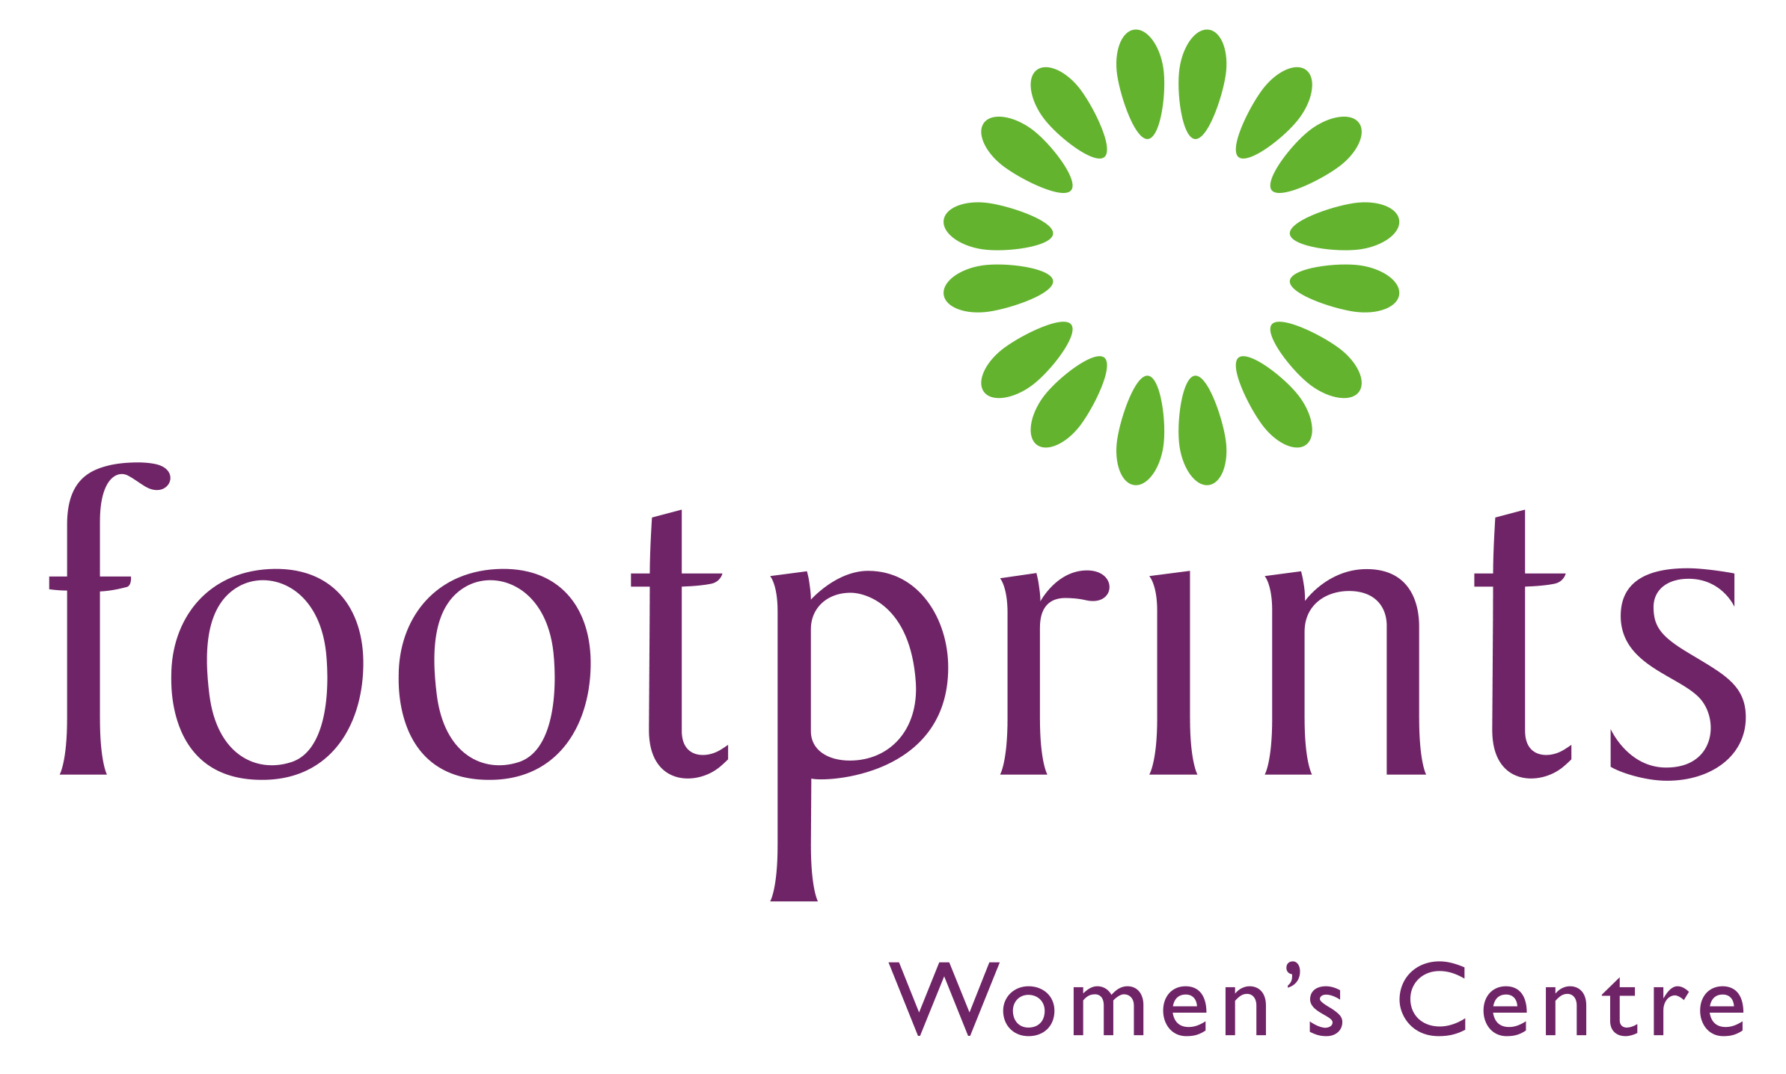

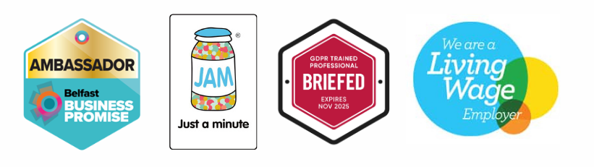

About Us

Our Mission
To enable women and children to ensure their voices are heard and that they take their rightful place in a just and equal society.

Our Vision
To eradicate inequalities that impact upon the lives of women and children.

Our Values

- To demonstrate Respect, listening actively to others and being non-judgemental.

- To provide Support through matching need.

- To underpin work with a Feminist Ethos that raises awareness of the inequalities experienced by women in society and provide interventions to redress the imbalance.

- To uphold Equality and recognise the value of Diversity across support delivery.

- To maintain Confidentiality in all our work and establish clear boundaries in the support we provide.

- To demonstrate Commitment to Footprints and generate positive energy and welcoming friendly atmosphere individually and collectively.

What we do

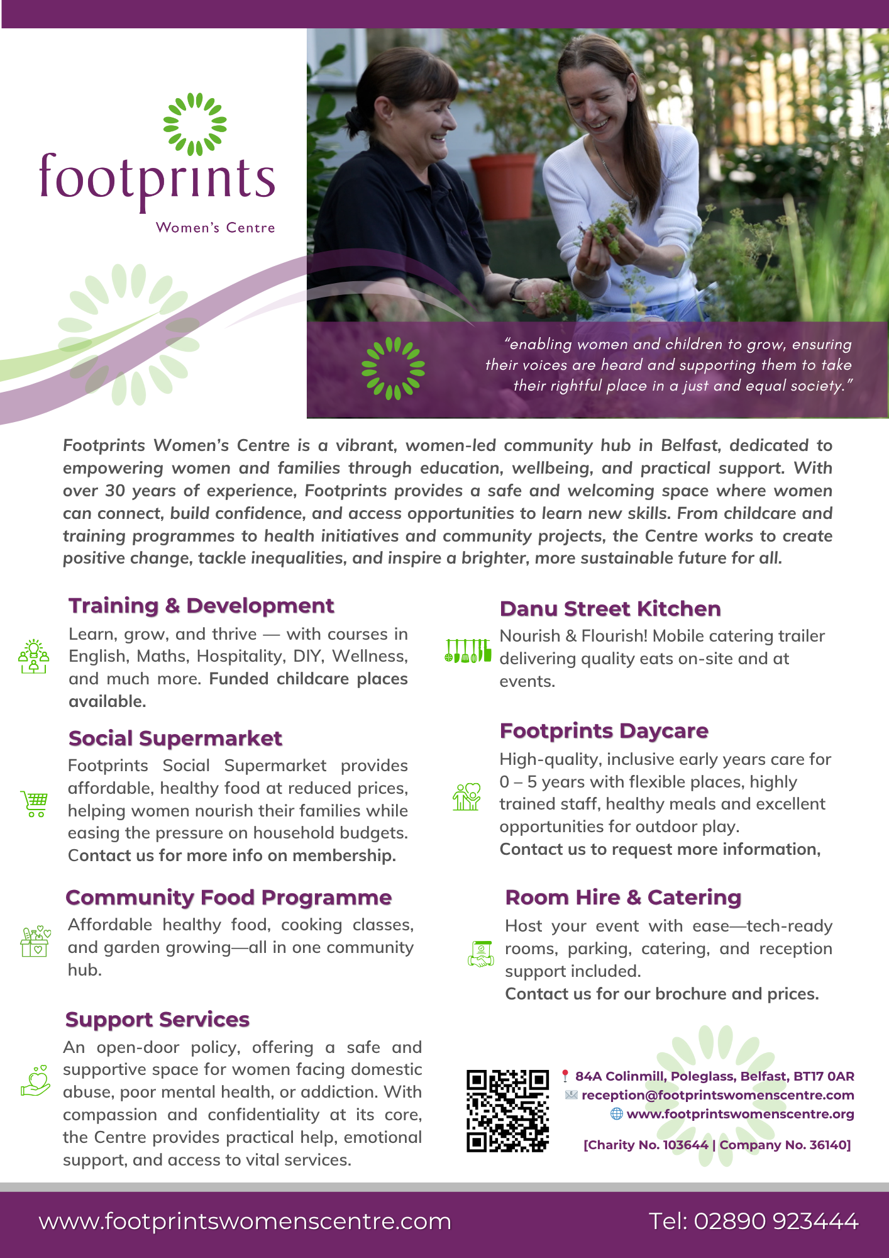

How we’re organised
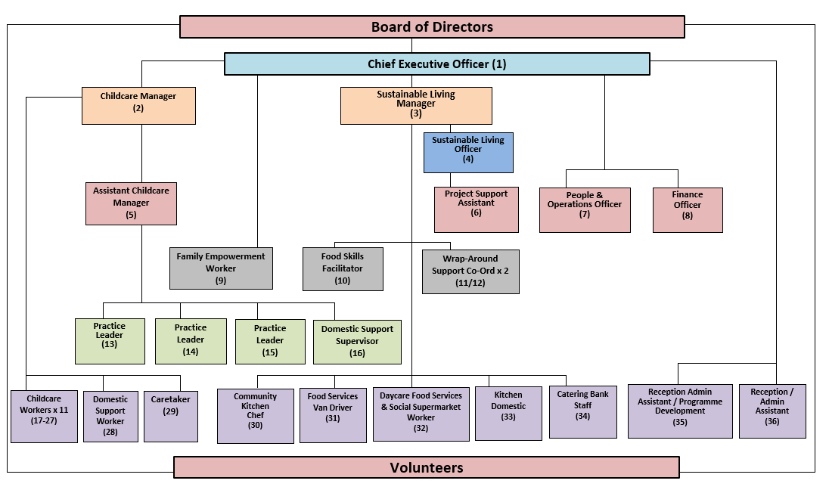

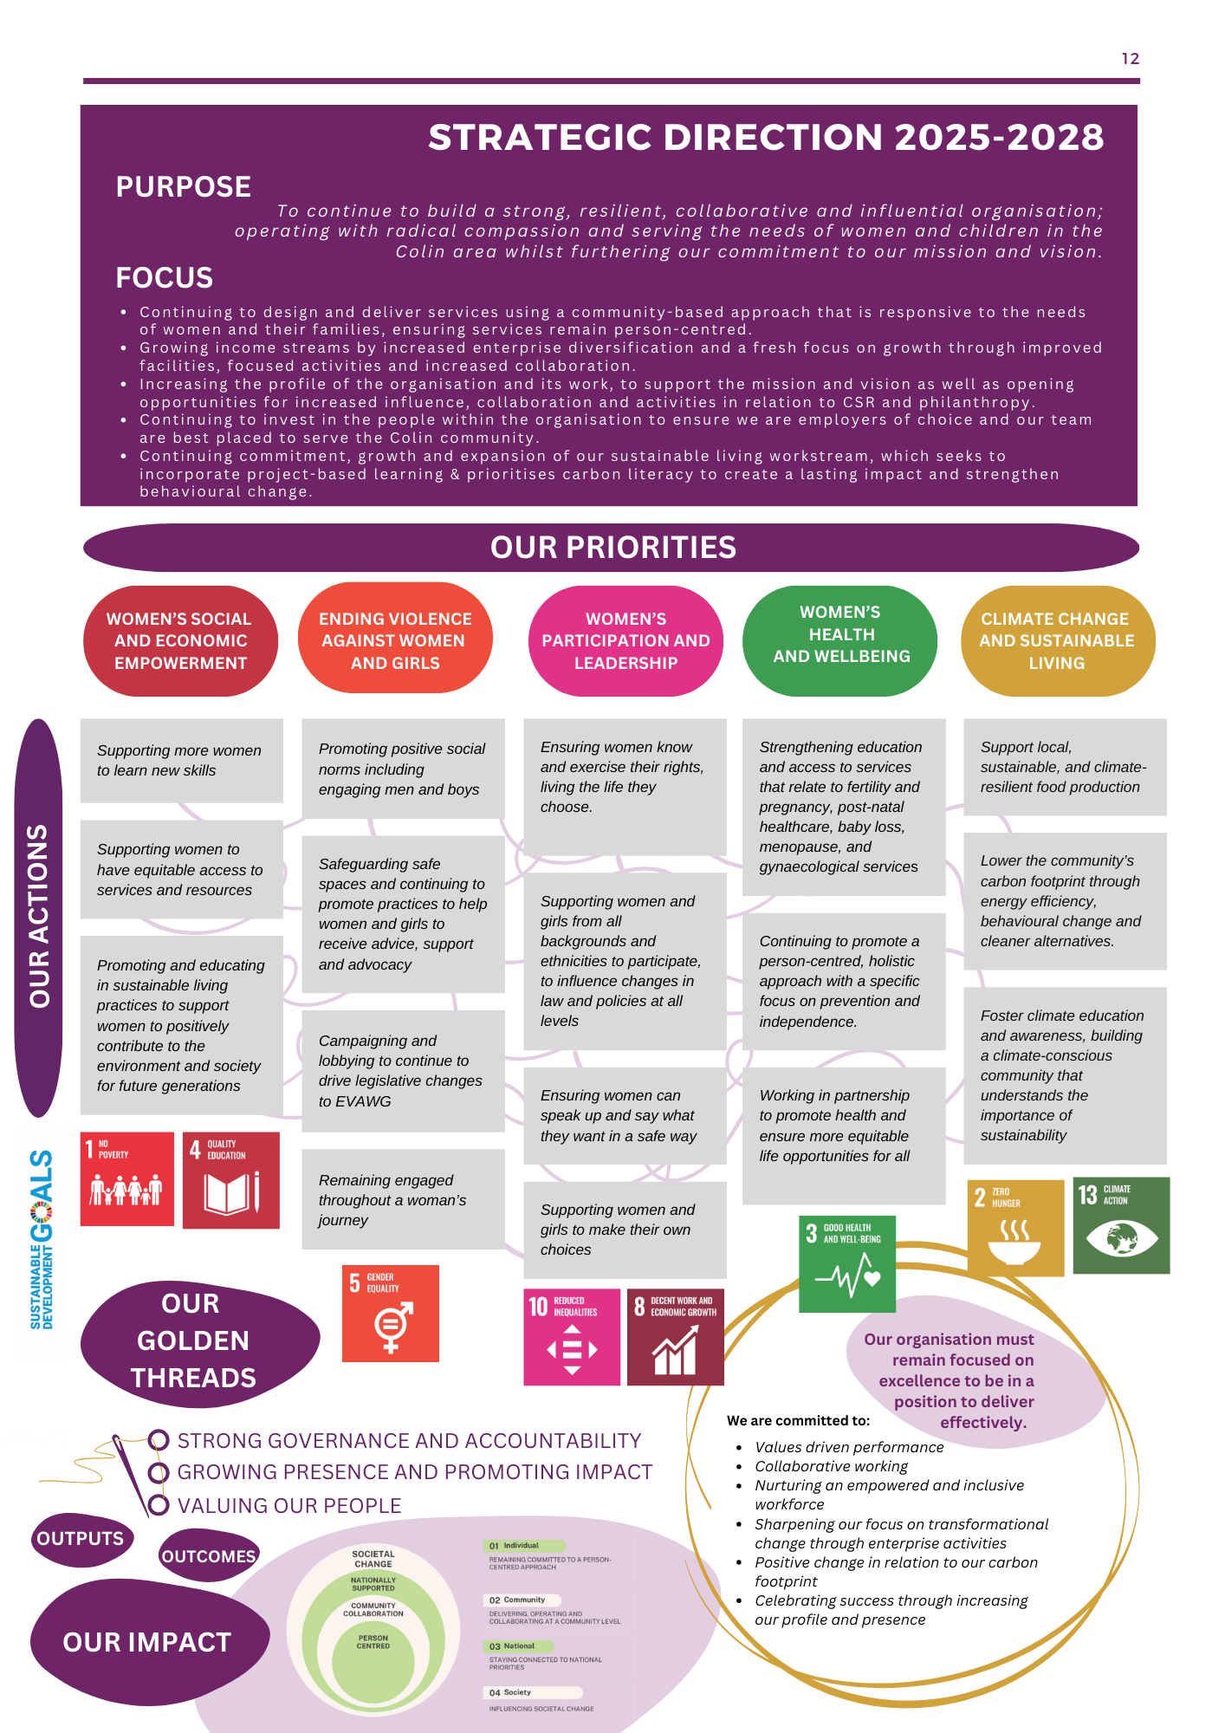

Benefits of working for us

1. Purpose-Driven Work

Contribute to meaningful change by advancing gender equality and climate justice.

2. Collaborative Culture

Be part of a supportive, inclusive team that values diverse voices and shared leadership.

3. Professional Growth

Access opportunities for training, mentorship, and skill development in gender, climate, and advocacy work.

4. Flexible Working Arrangements

Enjoy hybrid work options, flexible schedules and a focus on work-life balance.

5. Inclusive and Safe Workplace

We foster a work environment that prioritises care and respect.

6. Global and Local Impact

Collaborate with partners and communities driving feminist solutions to climate and social justice issues.

7. Comprehensive Benefits Package

- Competitive salary: £31,500 per annum
- 22 days paid leave plus 11 customary days each year
- Wellness support
- Mobile phone for business use
- Access to work vehicle for work related transportation
- Flexi-time arrangements
- Pension contributions – 3% employer contribution
- Personal development training
- Staff Appreciation Scheme

How to apply

Applicants are requested to submit the following documents as part of their application.

All submissions should be received by the closing date:
12 noon Monday 19th January 2026

To apply for this role please send the following information to: people@footprintswomenscentre.com

- ​An up-to-date CV (please send in word format)
All personal information will be removed before shortlisting is undertaken

- A supporting statement to a maximum of two sides of A4.
Please outline how your knowledge, skills, experience and values meet the requirement of the role.

- Competed Equal Opportunities Monitoring Form
This form will be removed before shortlisting is undertaken.

- Completed Referees Form
This form will be removed before shortlisting is undertaken. The form should have details of two referees; one should be your most recent employer if you have one. Referees will not be contacted unless you are successful at the interview stage.

We will contact you to advise if you have been shortlisted for interview.

Interviews will be held:
Week commencing: 2nd February 2026

Data Protection (UK GDPR)

All personal information provided during the recruitment process will be handled in accordance with the UK General Data Protection Regulation (UK GDPR) and the Data Protection Act 2018. Your data will be used for recruitment and selection purposes only, stored securely, and retained only as long as necessary. We will not share your information with third parties except as required for recruitment checks or by law.

Job Description

Job Title: Sustainable Living Officer

Responsible to: Sustainable Living Manager

*Location: Footprints Women’s Centre (see note below)

Hours: 35 Hours per week

Salary: £31,500 p.a. 3% employer pension contribution;

Leave entitlement: 22 days plus 11 statutory holidays

Introduction
Climate Conscious Communities is a five-year initiative, funded by National Lottery Community Fund, led by Footprints Women’s Centre (FWC) in partnership with Keep Northern Ireland Beautiful (KNIB), Fareshare NI and PricewaterhouseCoopers (PwC). It seeks to empower women and girls in communities across Northern Ireland to lead locally driven climate action and advocate for feminist climate justice. The project addresses both the structural inequalities that women face and the urgent need for community-level climate mitigation through practical, meaningful, and co-designed action.
Sustainable Living Officer Role
Footprints Women’s Centre is seeking a motivated and inspiring Sustainable Living Officer to champion our environmental initiatives. This exciting role will drive forward our vision to engage, educate, and empower women’s centres, their members, and wider communities across Northern Ireland to adopt environmentally sustainable behaviours, helping to reduce carbon footprints and promote climate-conscious living.

Key Roles and Responsibilities

1. Governance, Delivery and Management
- Work with the Sustainable Living Manager, Project Steering Group, and Project Partners to ensure strong project governance and alignment with project objectives.
- Lead project planning, scheduling, and milestone tracking to ensure timely and efficient delivery of outputs.
- Manage project budgets, support procurement processes, management of contracts, and resources effectively to achieve value for money and accountability.
- Manage day-to-day operations and line manage a Project Support Assistant to support delivery of project outcomes.

2. Communications
- Develop and implement a communication plan, including a campaign, to promote awareness and engagement among stakeholders and community members.
- Coordinate updates, newsletters, and digital content to highlight project outcomes and progress.
- Support the development of reports, case studies, and promotional materials for internal and external audiences.
- Promote the practices, benefits and impact of the women’s sector to support sustainable funding.

3. Representation & Stakeholder Engagement
- Act as a key representative of the project at meetings, forums, and community events.
- Build and maintain strong partnerships with key stakeholders including relevant agencies, community organisations and women’s centres.
- Facilitate collaboration and information sharing between project partners and stakeholders.

4. Record Keeping & Reporting
- Maintain comprehensive project records, documentation, and databases in accordance with GDPR.
- Monitor project performance, track outcomes, and report regularly to management, the project steering group, relevant sub committees and funding bodies.
- Prepare progress and monitoring exports, ensuring compliance with governance and funding requirements.

5. Risk Management & Continuous Improvement
- Identify potential risks and develop mitigation strategies to ensure project success.
- Evaluate project outcomes and recommend improvements for future initiatives.
- Contribute to organisational learning by sharing best practices and lessons learned.
- Ensure the evaluation framework is delivered and learning is shared.

6. Personal and Professional Development
- Participate in Footprint’s performance appraisal process
- Identify learning and development needs and evaluate training and development
- Contribute to the learning of others across the organisation, sharing knowledge and skills
- Collaborate with other staff to develop case studies and evidence of good practice.
Undertake any other work appropriate with the evolving objectives of the post and as may reasonable be requested by the Management Team at Footprints.
Ensure adherence to all Footprint’s policies and procedures.
Please note:
All staff are required to undergo Access NI checks with the Police Service for Northern Ireland and must be appropriately vetted for the protection of children and vulnerable adults at risk prior to commencement of employment.

*Location:
The postholder will be based at the primary location, Footprints Women’s Centre, but will work across other designated sites during the week, with one day per week of home working. As this is a new project and a newly established position, there is flexibility to adapt the role and working arrangements in line with evolving project needs. A work vehicle will be provided for travel to and from other sites. It is expected that over the course of the 5-year project that three designated sites are focused on each year, therefore the postholder must be willing to work flexibly across changing locations as project priorities develop.

Person Specification

Specification | Essential | Desirable
Proven experience in project/programme management/partnership initiatives preferably within sustainability/community development/business management | √
Strong organisational and time management skills with the ability to manage multiple priorities. | √
Excellent communication and stakeholder engagement skills. | √
Demonstrated ability to deliver projects within budget and to agreed timelines. | √
Proficiency in project management tools and Microsoft Office Suite. | √
Experience in managing people. | √
Sound knowledge of climate change drivers. | √
Experience in the Community and Voluntary Sector and an understanding of the issues facing NI communities. | √
Ability to work on own initiative with minimal supervision. | √
Excellent verbal and written communication skills | √
Experience in developing and publishing content on social media | √
Experience in the women’s sector/feminist-led sustainability or climate initiatives |  | √
Relevant training or qualifications in sustainability, energy efficiency, carbon literacy |  | √
Experience in developing campaigns to drive change | √
Experience in sustainability/climate action or providing support to individuals, businesses organisations or communities. |  | √
Qualification in project management, sustainability or a related field |  | √
Collaborative and proactive approach to teamwork | √
Adaptable, with strong problem solving and analytical skills | √
Passionate about sustainability and community outcomes | √
Full clean driving license | √

Footprints Women’s Centre
84a Colin Mill
Poleglass, Dunmurry
West Belfast
BT17 0AR

Charity Registration NIC103644 | A Company Limited by Guarantee NI036140

Please address any enquiries relating to the advertised position, and your submission to:

Charlene Murray
People & Operations Officer
Footprints Women’s Centre

Tel: 02890 923444
Email:people@footprintswomenscentre.com

